Name : Venkata vamsi siva Krishna Vura

LAB WORK-2

1.js-Fiddle showing google maps and video

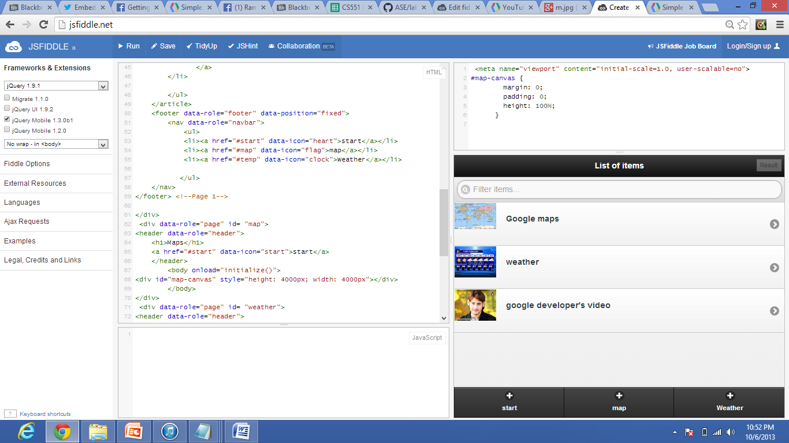

2. Google map showing the map using API (by changing the latitude and longitude we can get the map)

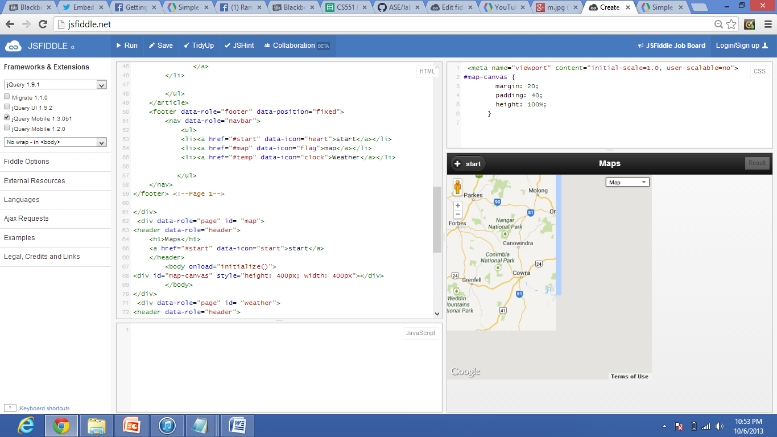

3. PRESENT temperature in US

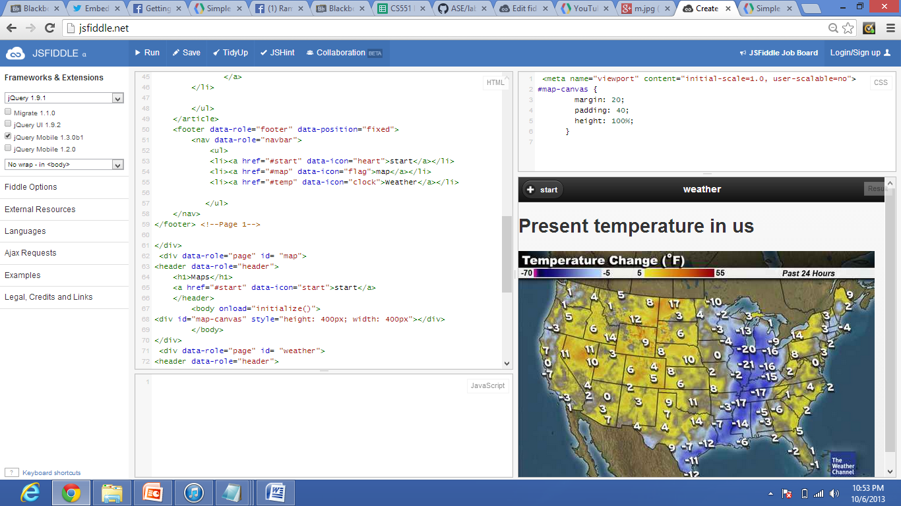

4.Embedded video in the fiddle

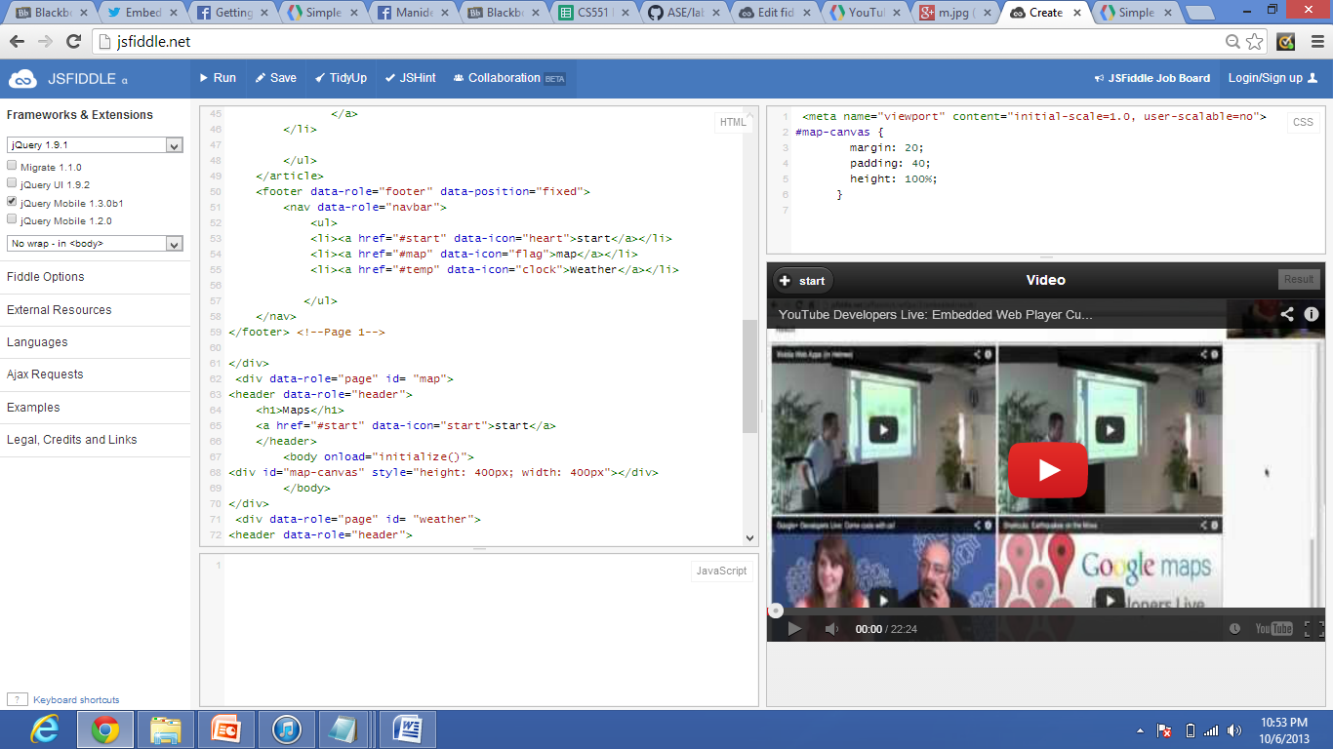

5. AT any time you can be returned to stop the video

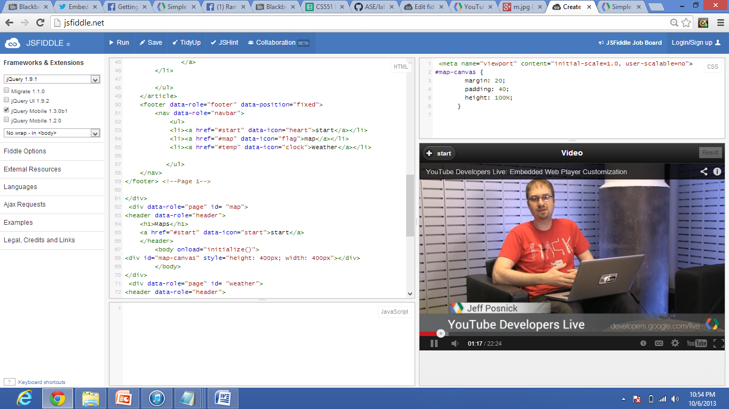

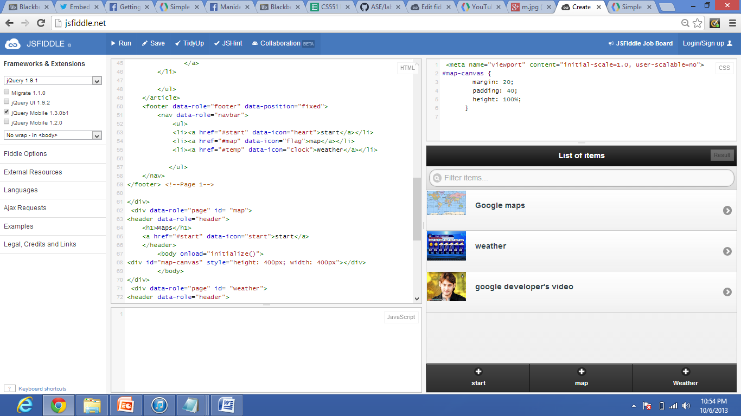

Link in jsFiddle:

<http://jsfiddle.net/8fDvr/>